Domestic demand continues to outpace exports
As regular readers of this column know, I have often talked about how the growth in domestic demand for corn has exceeded the growth in corn export demand and how our agricultural policies might be more successful if this factor were to be taken into account. Each time I have said this, someone has suggested that if the corn fed to exported animals was taken into consideration, the picture might look much differently.
Based on earlier calculations, I was confident that the corn fed to animals sold in the export market would not significantly change the overall picture. But data were needed for recent years. This past week APAC staff member Harwood Schaffer updated our numbers on the amount of corn exported via meat sold into international markets.
The major meat export categories are beef, pork and broilers. We don’t have access to the exact rations that were fed to export animals. However, we were able to construct a general ration that we used in conjunction with feed conversion rates to get a good handle on the amount of the various feed components that were exported as meat. We then adjusted both the corn domestic demand numbers and the corn export numbers by the net exports of grain used to produce the meat.
To keep things balanced out, we also made similar calculations for imported meat, making appropriate adjustments for such things as grass fed versus grain fed beef imports. Adjustments were NOT made, however, to reflect that a significant portion of broiler exports add little net demand for grain. This is because the birds were produced primarily for their breasts for domestic consumption and not the dark meat and giblets that were exported, but have little value otherwise. Virtually no whole broilers or chicken breasts are exported, except to Canada.
As one would expect, when grain fed to livestock is taken into consideration corn exports were higher and corn domestic utilization was lower than when feed exported as meat is not taken into consideration (fig. 1). In the 1996-2002 period, corn exported as meat added 14 percent to export levels.

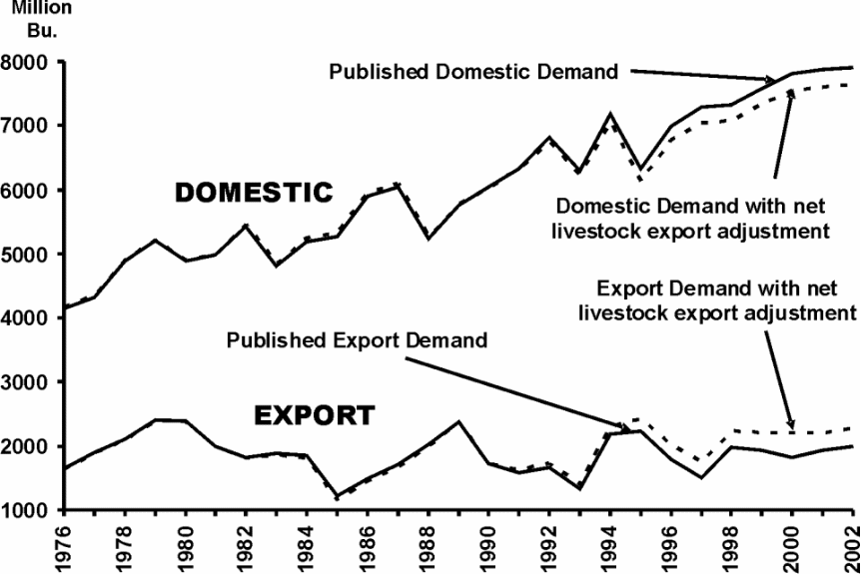

Figure 1. U.S. corn domestic demand and exports with and without adjustment for corn fed to net exported livestock, 1976-2002. Source: USDA, adjustments calculated by APAC.

In the 1996-2002 period, the adjusted corn exports accounted for 23 percent of U.S. corn utilization while in the 1976-1985 period the adjusted corn exports accounted for 28 percent. Considering the feed exported as meat, domestic demand still shows a strong upward trend while exports remain relatively flat.
I took a moment to look at the domestic industrial, alcohol and food utilization of corn and compared that with corn exports, adjusted for meat. In the 1990-2002 period the industrial, alcohol and food use for corn increased by an average of 68 million bushels a year while corn fed for export meat increased by an average of 22 million bushels (fig.2).

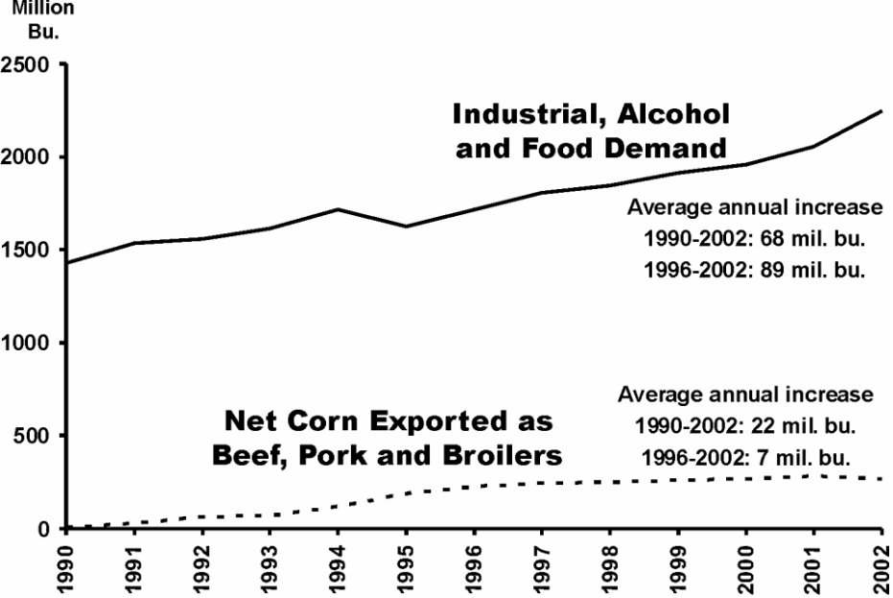

Figure 2. A comparison of domestic industrial, alcohol, and food demand for corn with export levels for corn exported as meat. Source: USDA, adjustments calculated by APAC.

Over the last six years the difference between the two uses is even more dramatic. The average annual increase in domestic industrial, alcohol and food demand for corn increased by 89 million bushels per year while corn fed to export meat, on average, increased by 7 million bushels per year. By way of comparison, feed demand for domestically consumed meat increased by an average of 61 million bushels of corn per year in the 1990-2002 period and an average of 47 million bushels per year over the last six years.
Corn exported as meat has increased the export demand for corn, especially since 1990. It also has lifted the 1996-2002 adjusted corn exports above the average achieved for the 1976-1985 period. However this increase was not enough to enable corn exports to maintain the relative levels of the 1976-1985 period when exports accounted for 28 percent of U.S. corn utilization compared to 23 percent in the most recent period.
Corn domestic demand continues to outpace corn exports despite opinion to the contrary among the general populace.

Daryll E. Ray holds the Blasingame Chair of Excellence in Agricultural Policy, Institute of Agriculture, University of Tennessee, and is the Director of the UT’s Agricultural Policy Analysis Center. (865) 974-7407; Fax: (865) 974-7298; dray@utk.edu; http://www.agpolicy.org.

Reproduction Permission Granted with:
1) Full attribution to Daryll E. Ray and the Agricultural Policy Analysis Center, University of Tennessee, Knoxville, TN;
2) An email sent to hdschaffer@utk.edu indicating how often you intend on running Dr. Ray’s column and your total circulation. Also, please send one copy of the first issue with Dr. Ray’s column in it to Harwood Schaffer, Agricultural Policy Analysis Center, 310 Morgan Hall, Knoxville, TN 37996-4500.

